The Road Helper

Project Graphic

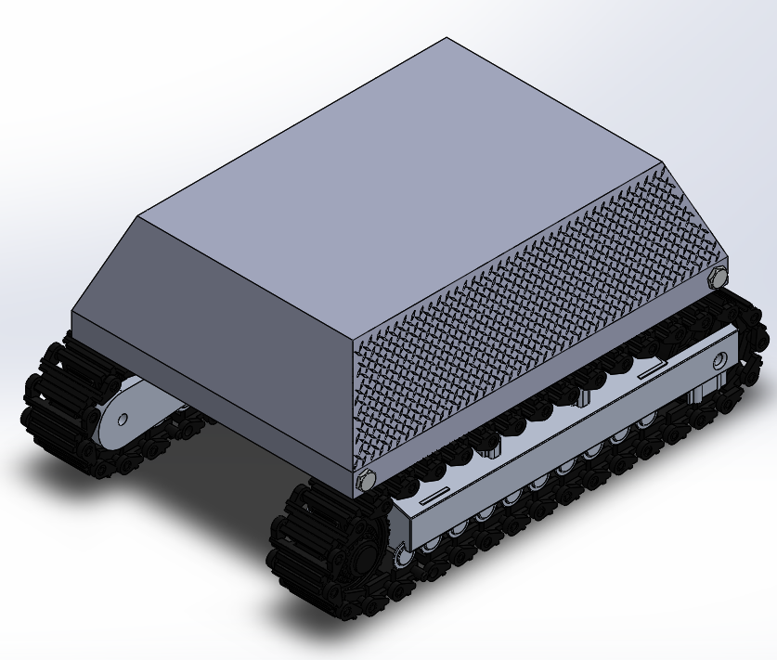

TPG, The Pineapple Guys

Brodie Hamlin, Drew Swanson, Logan Dice, Ryan Fuglvog

Cedarcrest High School

3/9/2021

1. **Introduction (2 points)**
   1. The purpose of the Road Helper is to automate the blocking off and sectioning off of roads in a construction area. Additionally, the road helper would contain all necessary tools to carry out this task.
2. **Target Market (2 points)**
   1. Construction industry mainly. This machine would cut down cost for roadside projects a lot, because it can the work equivalent to a whole team of blockers and whatnot.
3. **Requirements (4 points)**
   1. Our Road Helper was meant to be able to replace all the odd jobs of a construction worker. This includes setting up cones, controlling the STOP or SLOW signs, and blocking off the construction zone on its own.
   2. Give specific and appropriate supporting details. Use as many paragraphs as needed to fully explain. (You may also embed screen shots.) The Road Helper can move around the construction site easily, as it has a 12 by 16-foot frame and construction grade omni-directional treads. It is also environmentally friendly as it is powered by an electric engine. The Road Helper was also meant to have STOP, SLOW, and CONSTRUCTION signs, even though they were not added to the final product.
4. **Product Ideas (4 points)**
   1. Initially, it stemmed from the idea to make a vehicle of some sorts. From there, we narrowed it down to things that would solve a problem. We settled on The Road Helper because it seemed like a cool thing to make. From there, we started brainstorming tasks it could automate, and we settled on, you know, **all of them**. The Road Helper can singlehandedly block off a road or construction zone on the road.
   2. We met the requirements because we set the requirements. In all seriousness though, we met the requirements by dividing up the work and setting goals for it very clearly. The Road Helper’s features were laid out in detail so that each member knew what needed to be done.
5. **Product Sketches (4 points)**
   1. Include your sketches and descriptions of those sketches. (The sketches can be in the appendix.)

We wanted to go for a tread based vehicle that was electric so we combine a few different ideas and came up with a truck sized vehicle that would help in construction while also being full automatic as well as electric.

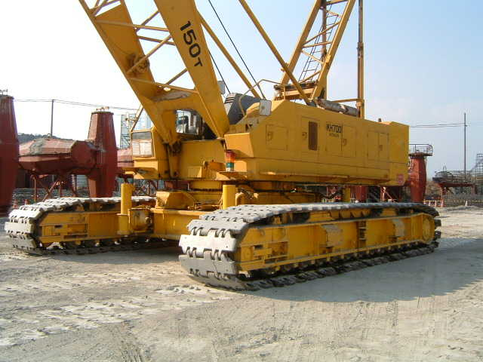 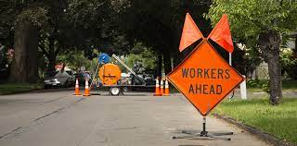

1. **Success in Creating Product (4 points)**
   1. We were pretty successful. We created the entire structure, and got it functioning, but we do not have any of the attachments on it. This is mostly due to the fact that our compadre, Drew Swanson, was removed from our class. This put a huge cramp on the teamwork in that area, and thus, the attachments portion of our project was not completed in full.
   2. I honestly do not have the slightest idea what to include here. The question is asking for supporting details that show we were successful in making our project? Well, the models, drawings, and assembly should be proof of success in and of itself. Hence, I will just leave it at that. Drawings, screenshots of models, and screenshots of the assembly will be included in this write-up.
2. **Lessons Learned (4 points)**
   1. One lesson learned is that without a team manager, it’s hard to coordinate what we’re doing and work on pace with each other in such a large group. Another lesson learned is that it’s really hard to only communicate through text and email. It would be much better to talk together on a voice call or meet in person.
   2. Even though working in larger groups may seem like you can get more work done, its really hard to coordinate when there is no one in charge. Most of us were doing our own thing and that made it hard to get everything together when the time had come. Next time we should either work in smaller groups or put someone in charge of “bossing” the group around. It’s also really hard to communicate through text and email. It is much easier to get together in person or get on a voice call. We rarely got on a voice call to do synchronous work, but when we did it was much easier to coordinate.
3. **Skills Learned (4 points)**
   1. Answer the question: What specific technical skills did you learn? And tell how you would teach at least one skill.

Many skills were learned throughout the process of building the road helper but perhaps one of the main skills learned was how to scale in multiple ways, such as using a sketch scale or a scaling feature can allow you to scale entire features to the size you want them instead of having to go through and change everything. Using this function in the sketch format allows you to keep certain relations that could cause problems if the sketch was not scaled. This is a relatively easy to teach as you could easily show some one how this could be applicable for a multipart assembly and maybe one or two parts were done at a smaller scale and can easily be corrected to fit.

* 1. Give specific and appropriate supporting details. Use as many paragraphs as needed to fully explain. (You may also embed screen shots.)

The scale feature can be found under the features tab. One thing to note is a scale feature cannot be used on an entire assembly but can be used on an assembly multipart meaning that if you save an assembly as one full body you can then scale all of the parts in that assembly at once.

1. **Description of Product Drawings (2 points)**
   1. Describe the drawings that you have for your project. Point out specific details in your drawings of how your project met the requirements you set out to meet.

There were three main parts to the

1. **Product Drawings (6 points)**
   1. Include product drawings with appropriately filled in title blocks, dimensions, notes, etc.

(all product drawings can be found sectioned under the product drawings and renderings document)

1. **Product Renderings and/or Physical Models (4 points)**
   1. Put together enough renderings to show off your product. (3) These renderings (and /or pictures of physical models) must show case the product in the best light for customers or potential customers to want to obtain the product. Also give a short explanation of how you would go about appealing to customers (1).

(all product drawings can be found sectioned under the product drawings and renderings document)

**Appendix/Notes**

You can put other notes or thoughts into the Appendix/Notes section. These are thoughts or notes that do not fit into the other categories but add to the understanding of the product. The Appendix/Notes section may be deleted if not used.

By the way, edit the header (put the title of your project) and footer (replace “Name” with your name so that it appears on each page).